ADO.NET Connection with AdventureWorks (Using VS Code)

1. Objective
To connect the AdventureWorks database (SQL Server) with a C# application using ADO.NET in Visual Studio Code.
2. Prerequisites
Make sure the following are installed:
Software Requirements
- SQL Server (Express/Developer)
- SQL Server Management Studio
- Visual Studio Code
- .NET SDK
Database Requirement
- AdventureWorks database (e.g., AdventureWorks2022) attached in SSMS

3. Project Setup
Step 1 — Create a new Console App
Open terminal:
dotnet new console -n AdoNetDemo
cd AdoNetDemo
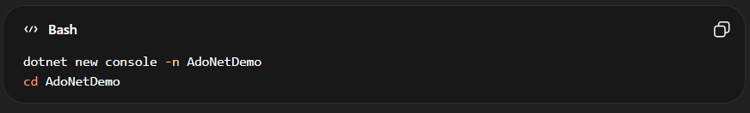
Step 2 — Open Project in VS Code
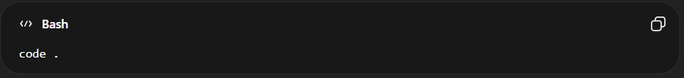
4. Install Required Dependencies
Install SQL Client Library
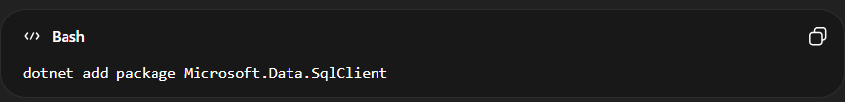
Why?
This package allows your C# application to communicate with SQL Server.
5. Configure Connection String
SQL Server:
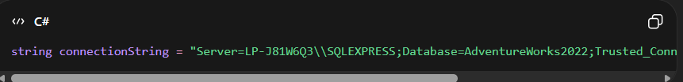
Explanation :
Parameter | Meaning
Server | SQL Server instance
Database | Target database
Trusted_Connection | Uses Windows Authentication
TrustServerCertificate | Bypass SSL certificate validation (local only)

6. Write ADO.NET Code
Open Program.cs and replace everything with:
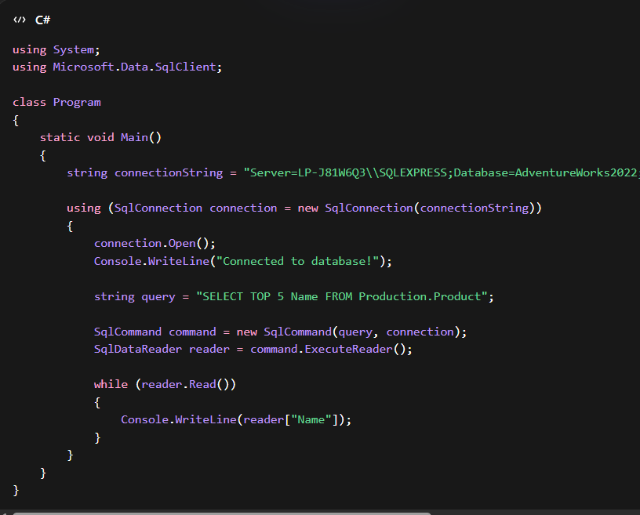
C# Code ::
using System;
using Microsoft.Data.SqlClient;

class Program
{
static void Main()
{
string connectionString = "Server=LP-J81W6Q3\\SQLEXPRESS;Database=AdventureWorks2022;Trusted_Connection=True;TrustServerCertificate=True;";

using (SqlConnection connection = new SqlConnection(connectionString))
{
connection.Open();
Console.WriteLine("Connected to database!");

string query = "SELECT TOP 5 Name FROM SalesLT.Product";

SqlCommand command = new SqlCommand(query, connection);
SqlDataReader reader = command.ExecuteReader();

while (reader.Read())
{
Console.WriteLine(reader["Name"]);
}
}
}
}
7. Run the Application:
In terminal:

Expected Output:
